Stanescu Maria-Raluca

Grupa 132

Tema 2

1. SELECT j.job_title as NumeJob_SMR, j.min_salary as SalMin_SMR, j.max_salary as SalMax_SMR, e.first_name as Prenume_SMR,e.last_name as Nume_SMR,e.employee_id as ID_SMR,d.department_name as NumeDepartament_SMR

FROM jobs j

LEFT OUTER JOIN employees e ON (j.job_id=e.job_id)//parcurgem employees si verificam egalitatea pt //job_id

LEFT OUTER JOIN departments d ON (d.department_id = e.department_id) )//parcurgem departments si verificam egalitatea pt department_id

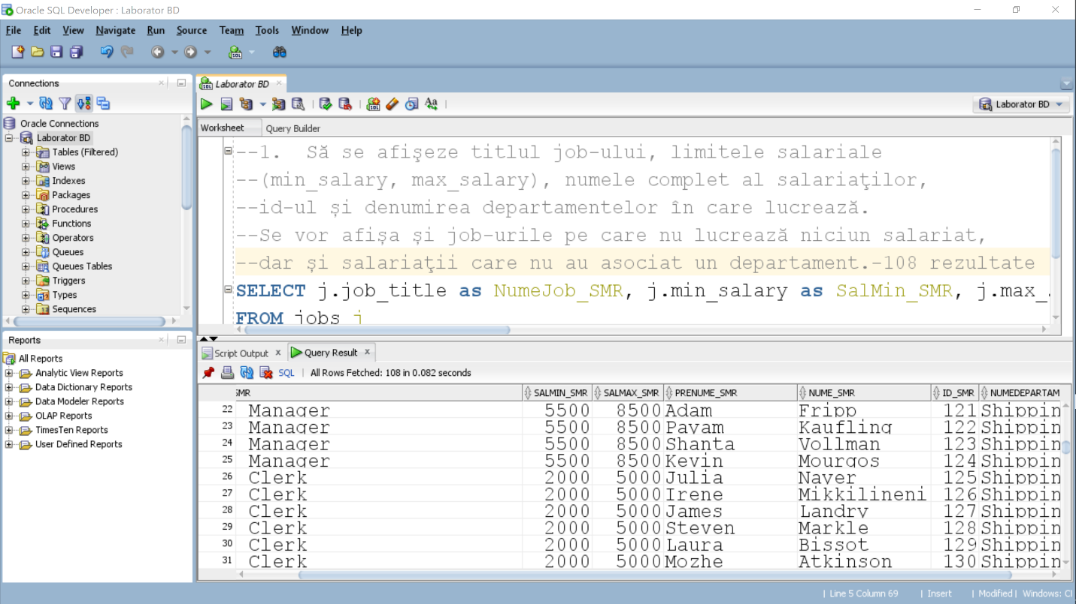

2. SELECT 'Departamentul ' || d.department_name || ' este condus de ' || NVL(TO_CHAR(d.manager_id), 'nimeni') || ' si nu are salariati.' as INFO_SMR

FROM departments d

WHERE d.department_id IN (SELECT department_id FROM departments MINUS SELECT department_id FROM employees)

UNION // intersectam departamentele cu angajati cu cele fara.

SELECT 'Departamentul ' || d.department_name || ' este condus de ' || NVL(TO_CHAR(d.manager_id), 'nimeni') || ' si are salariati.' as INFO_SMR//folosim nvl pentru afisarea a ‚’nimeni ’ in cazul d.manager_id is NULL

FROM departments d

WHERE d.department_id NOT IN (SELECT department_id FROM departments MINUS SELECT department_id FROM employees)

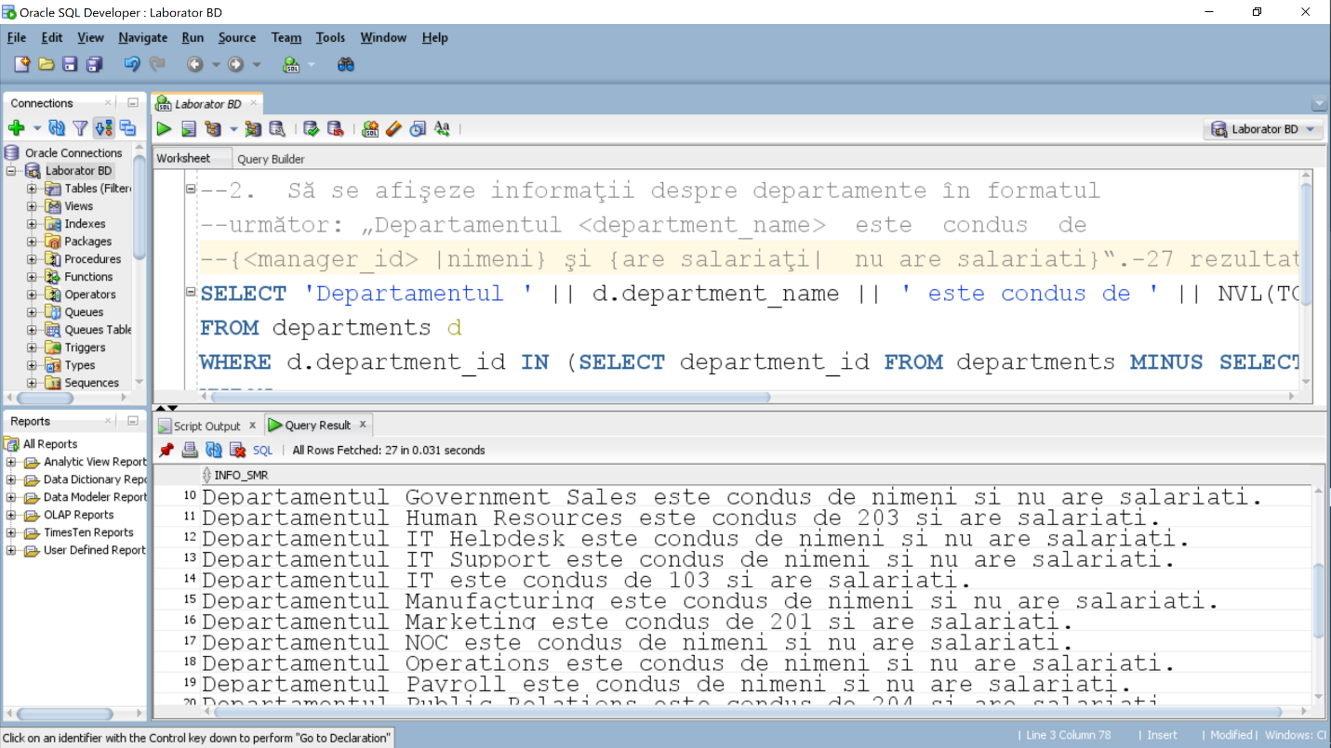

3. SELECT e.last_name as Nume_SMR,e.first_name as Prenume_SMR,LENGTH(e.last_name) as Lungime_SMR,l.city as City_SMR //selectam datele pt afisare

FROM employees e

LEFT OUTER JOIN departments d ON (e.department_id = d.department_id)//parcurgem departments si //verificam egalitatea dintre id-uri

LEFT OUTER JOIN locations l ON (d.location_id = l.location_id)//parcurgem locations si verificam //egalitatea dintre id-uri

WHERE LENGTH(e.first_name) != LENGTH(e.last_name);//conditia pentru lungime diferita a numelui si //prenumelui

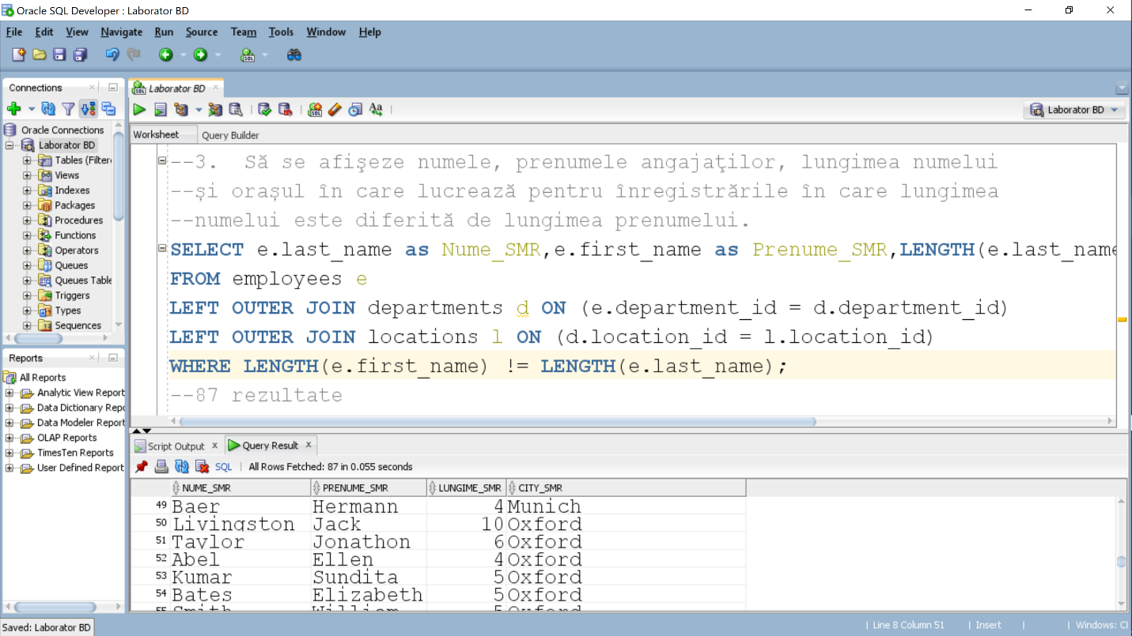

4.

1.Decode

SELECT e.last_name as Nume_SMR, e.hire_date DataAngajare_SMR, j.job_title Job_SMR, e.salary Salariu_SMR, DECODE(EXTRACT(YEAR FROM e.hire_date), 1989, 1.2*e.salary, 1990, 1.15*e.salary,1991, 1.1*e.salary, e.salary) as SalariuModificat_SMR // cautam cu decode anul angajarii si marim salariile in functie de anul angajarii(1989.1990,1991) , iar in pentru restul angajatilor salariul ramane acelasi

FROM employees e

LEFT OUTER JOIN jobs j ON (e.job_id = j.job_id);

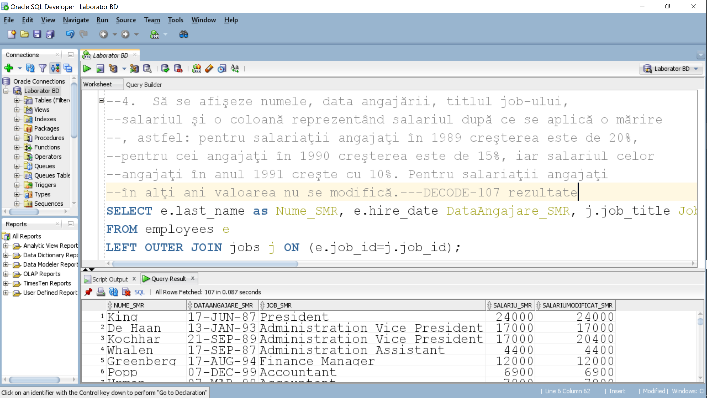

2.Case

SELECT e.last_name as Nume_SMR, e.hire_date as DataAngajare_SMR, j.job_title as Job_SMR, e.salary as Salariu_SMR,

CASE

WHEN EXTRACT(YEAR FROM e.hire_date) = 1989 THEN 1.2 * e.salary

WHEN EXTRACT(YEAR FROM e.hire_date) = 1990 THEN 1.15 * e.salary

WHEN EXTRACT(YEAR FROM e.hire_date) = 1991 THEN 1.1 * e.salary

ELSE e.salary //modificam salariul cu ajutorul case si folosim else pentru a pastra acelasi salariu pentru //angajatii cu hire_date diferit de 1989,1990,1991.

END as SalariuModificat_SMR

FROM employees e

LEFT OUTER JOIN jobs j ON (e.job_id = j.job_id);

